

April 26, 2024

Planning and progress REPORT

Repository: https://github.com/C1-010/Acme-SF-D03

Group: C1.010

García Rivero, Andrés Francisco -[andgarriv@alum.us.es](mailto:andgarriv@alum.us.es)

López Cubiles, Antonio José - [antlopcub@alum.us.es](mailto:antlopcub@alum.us.es)

Nieto Vicioso, Javier - [javnievic@alum.us.es](mailto:javnievic@alum.us.es)

Díaz Ordoñez, Pablo -  [pabdiaord@alum.us.es](mailto:%20pabdiaord@alum.us.es)

Sevillano Barea, Alejandro - [alesevbar@alum.us.es](mailto:alesevbar@alum.us.es)

Content Table

1. Executive Summary 2

2. Revision Table 2

3. Introduction 2

4. Contents 3

4.1 Planification 3

4.2 Progress 9

5. Conclusions 11

6. Bibliography 11

# 1. Executive Summary

This reportoffers an insightful reflection on the overall performance and achievements of Sprint 3 within the project's development cycle. It incorporates analyses from clockify reports to gauge personal productivity, task board snapshots capturing task progress throughout the sprint. Additionally, the document delves into the cost analysis of personnel derived from clockify data, essential for client invoicing purposes. By synthesizing these elements, the report provides a comprehensive understanding of Sprint 3's progress and sets a solid foundation for future iterations of the project.

# 2. Revision Table

|  |  |  |
| --- | --- | --- |
| Revision number | Date | Description |
| 1 | 26/04/2024 | Created this document and finished it. |

# 3. Introduction

This report offers a detailed insight into the progress and planning efforts throughout the group´s development. During this period, we produced reports, and we implemented the initial mandatory and supplementary requirements. Almost all tasks were completed within the designated timeframe. We used clockify to have a better coordination and knowledge of the real time we spent on this sprint and also the estimated hours.

We estimated a budget considering work hours and associated costs, to provide an overview of the progress achieved to date and establish a solid foundation for future iterations.

This report begins with an Executive Summary, offering a concise overview of Sprint 3's performance, including insights from clockify reports and colleague evaluations. It is followed by a Revision Table, detailing any document revisions. The Introduction outlines Sprint 3's focus on Implementing features and project planning, setting the stage for further exploration. The Contents section provides a roadmap of the report's structure. Planification includes task board screenshots and budget breakdowns, while Progress evaluates team performance and addresses conflicts. Cost Comparison compares estimated and actual costs. Conclusions summarize key findings, and the Bibliography remains intentionally blank.

# 4. Contents

**

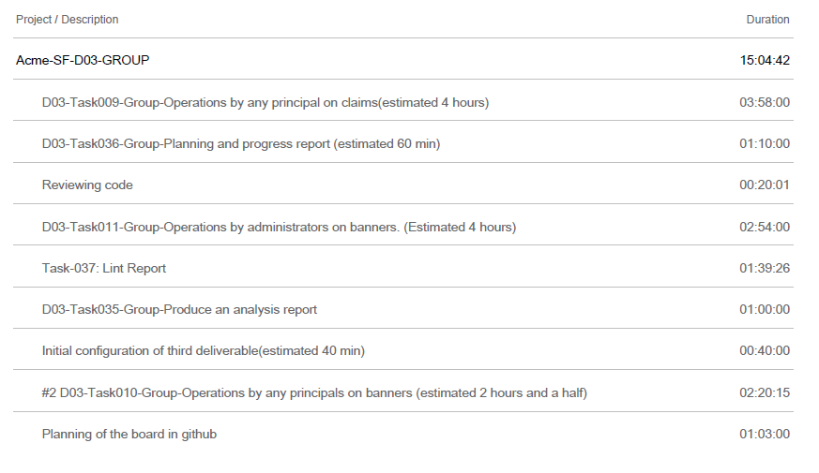

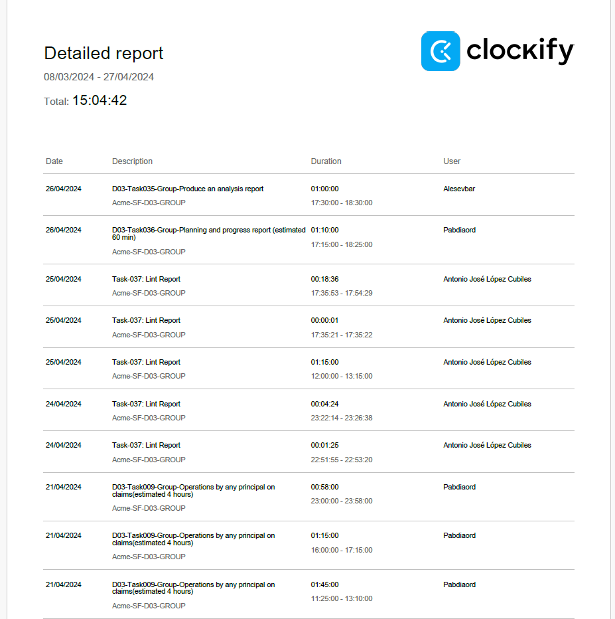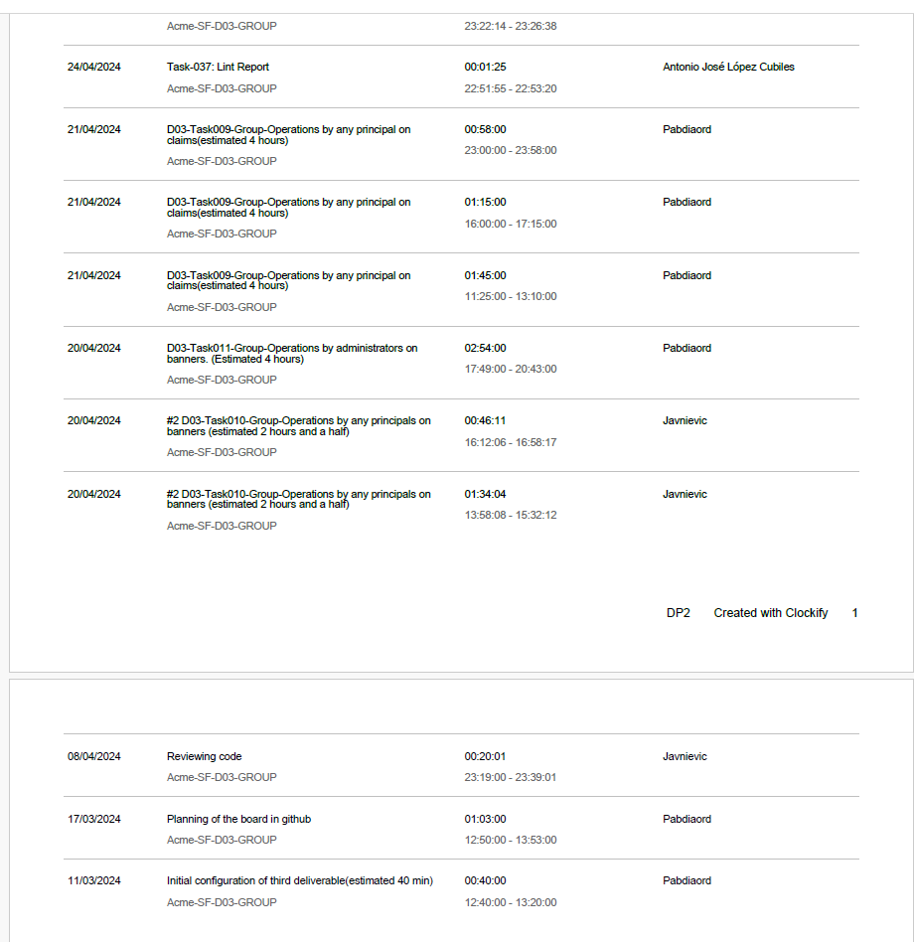

**Screenshots**:

Initial screenshot of tasks in the "to do" column.

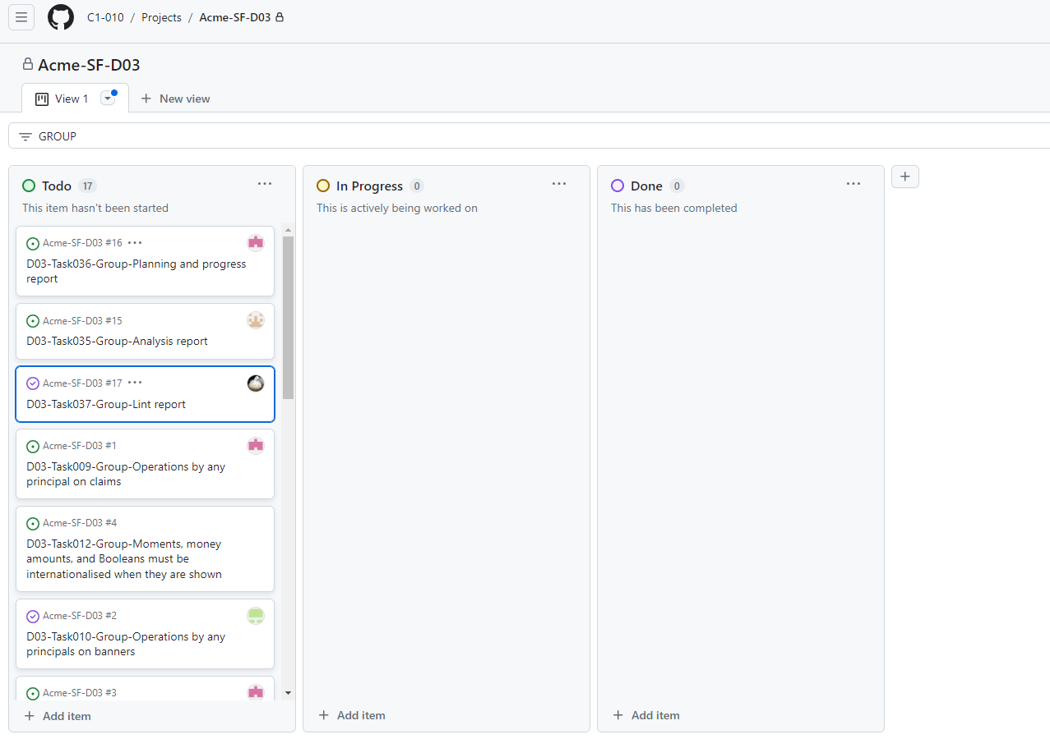

Intermediate screenshot showing all tasks in all columns.

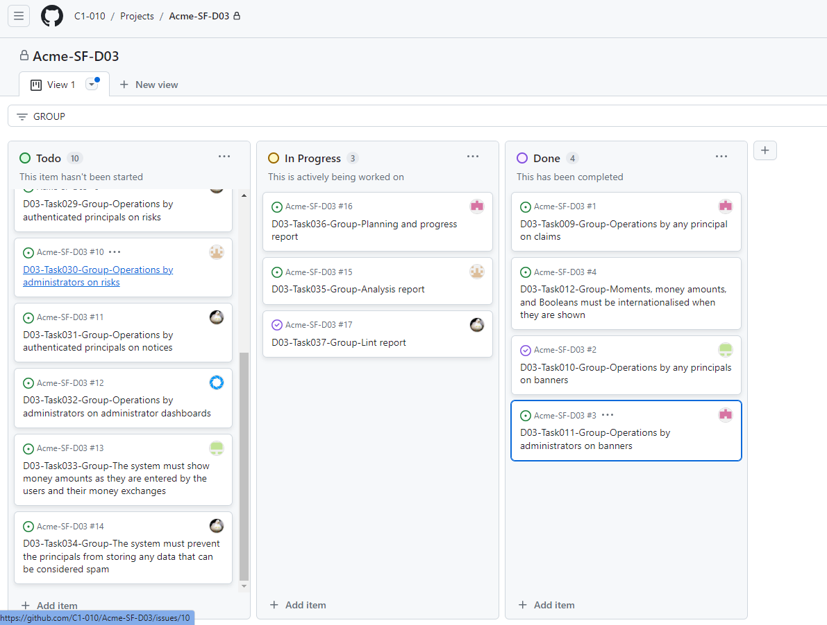

Screenshot at the end of the deliverable showing tasks in the "done" column.

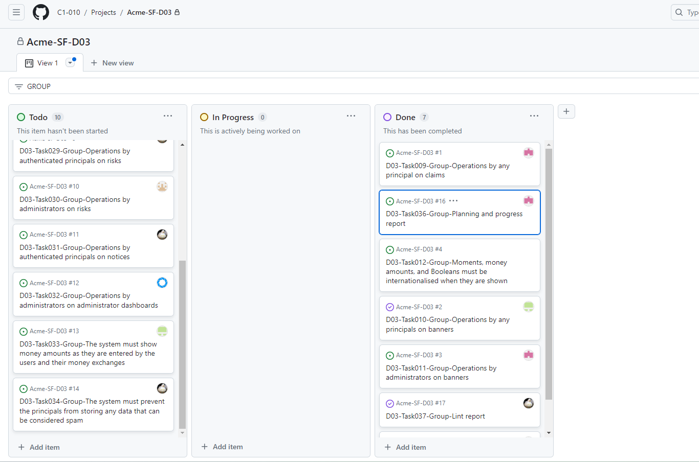

**Budget**:

|  |  |  |  |  |
| --- | --- | --- | --- | --- |
| **Task** | **Role** | **Salary per minute** | **Estimated time (minutes)** | **Estimated Cost (€)** |
| Task-000-Initial configuration | Manager | 0,5 | 40 | 20 |
| Task-000-GitHub board | Manager | 0,5 | 60 | 30 |
| Task-000-S4-code-review | Tester | 0,33 | 20 | 6,6 |
| Task-010-Op. principals on banners | Developer | 0,33 | 150 | 49,5 |
| Task-011-Op. administrators on banners | Developer | 0,33 | 240 | 79,2 |
| Task-009-Op. principal on claims | Developer | 0,33 | 240 | 79,2 |
| Task-012-Moments, money, Booleans internationalised | Developer | 0,33 | 65 | 21,45 |
| Task-037 Lint report | Analyst | 0,5 | 90 | 45 |
| Task-035 Analysis report | Analyst | 0,5 | 60 | 30 |
| Task-036 P&P report | Analyst | 0,5 | 60 | 30 |
|  |  |  |  |  |
| TOTAL |  |  | 1035 | 390,95 |

Total Number of Estimated Minutes: 1035 minutes

Personnel Cost: 390,95 €

## 4.2 Progress

**Conflict and Resolution**:

There have been some conflicts with any group member due to some members of the group did not prove what they were committing to the main branch, this caused a little delay in the delivery.

**Cost Comparison**:

After making the deliverable, a comparison was made between the estimated cost in the previous planning and the actual cost. Details include the number of hours spent, personnel costs, and amortization costs, as outlined below:

|  |  |  |  |  |
| --- | --- | --- | --- | --- |
| **Task** | **Role** | **Salary per minute** | **Real Time(minutes)** | **Real Cost (€)** |
| Task-000-Initial configuration | Manager | 0,5 | 40 | 20 |
| Task-000-GitHub board | Manager | 0,5 | 63 | 31,5 |
| Task-000-S4-code-review | Tester | 0,33 | 20 | 6,6 |
| Task-010-Op. principals on banners | Developer | 0,33 | 140 | 46,2 |
| Task-011-Op. administrators on banners | Developer | 0,33 | 174 | 57,42 |
| Task-009-Op. principal on claims | Developer | 0,33 | 238 | 78,54 |
| Task-012-Moments, money, Booleans internationalised | Developer | 0,33 | 65 | 21,45 |
| Task-037 Lint report | Analyst | 0,5 | 98 | 49 |
| Task-035 Analysis report | Analyst | 0,5 | 60 | 30 |
| Task-036 P&P report | Analyst | 0,5 | 70 | 35 |
|  |  |  |  |  |
| TOTAL |  |  | 968 | 375,71 |

Total Number of Real Minutes: 968 minutes

Personnel Real Cost:  375,71 €

**Guidance table**:

|  |  |  |  |  |  |  |
| --- | --- | --- | --- | --- | --- | --- |
| **Task** | **Role** | **Salary per minute** | **Estimated time (minutes)** | **Estimated Cost (€)** | **Real Time(minutes)** | **Real Cost (€)** |
| Task-000-Initial configuration | Manager | 0,5 | 40 | 20 | 40 | 20 |
| Task-000-GitHub board | Manager | 0,5 | 60 | 30 | 63 | 31,5 |
| Task-000-S4-code-review | Tester | 0,33 | 20 | 6,6 | 20 | 6,6 |
| Task-010-Op. principals on banners | Developer | 0,33 | 150 | 49,5 | 140 | 46,2 |
| Task-011-Op. administrators on banners | Developer | 0,33 | 240 | 79,2 | 174 | 57,42 |
| Task-009-Op. principal on claims | Developer | 0,33 | 240 | 79,2 | 238 | 78,54 |
| Task-012-Moments, money, Booleans internationalised | Developer | 0,33 | 65 | 21,45 | 65 | 21,45 |
| Task-037 Lint report | Analyst | 0,5 | 90 | 45 | 98 | 49 |
| Task-035 Analysis report | Analyst | 0,5 | 60 | 30 | 60 | 30 |
| Task-036 P&P report | Analyst | 0,5­ | 60 | 30 | 70 | 35 |
|  |  |  |  |  |  |  |
| TOTAL |  |  | 1035 | 390,95 | 968 | 375,71 |
|  |  |  |  |  | Amortisation* | 125,236 |

*The amortisation is computed using a linear method along three years’ time

**Estimated time:** 1035 minutes.

**Actual time:**  968 minutes.

**Difference:** -67 minutes

**Estimated Cost:** 390,95€

**Actual Cost:** 375,71€

**Difference:**   -15,24€

# 5. Conclusions

In conclusion, Sprint 3 has provided valuable insights into the project's progress and performance. Utilizing Clockify reports and task board snapshots has enhanced productivity and task management, facilitating better coordination among team members. The detailed cost analysis of personnel has improved financial transparency, while the absence of conflicts reflects a positive team dynamic conducive to collaboration. Moving forward, refining the budgeting process based on the comparison between estimated and actual costs will be essential for more accurate estimations in future iterations. Overall, Sprint 3 has laid a solid foundation for the project's continued development, with lessons learned and recommendations informing strategies for ongoing improvement.

# 6. Bibliography

Intentionally blank.